Name: Sainyam Agrawal

Roll: 20BCY10151

**Assignment 3**

Analysis->

The 3 algorithms will explain the following 4 points.

1. Briefly explain how the algorithm works.

2. Discuss the key strengths and advantages of the algorithm.

3. Identify any known vulnerabilities or weaknesses.

4. Provide real-world examples of where the algorithm is commonly used.

AES (Advanced Encryption Standard):

1. The AES (Advanced Encryption Standard) algorithm works by taking a plain text input and a secret key and transforming them through a series of cryptographic operations. It operates on 128-bit blocks of data and supports key sizes of 128, 192, and 256 bits. The algorithm consists of several rounds of substitution, permutation, and mixing operations, which create confusion and diffusion, making it highly resistant to cryptographic attacks. The resulting cipher text is the encrypted form of the original input.
2. Key strengths and advantages of the AES algorithm include:

* Security: AES has been extensively analysed by cryptographers worldwide and is considered secure against a wide range of attacks, including brute force, differential, and linear cryptanalysis.
* Efficiency: AES is computationally efficient, allowing for fast encryption and decryption on modern computer systems.
* Flexibility: It supports key sizes of 128, 192, and 256 bits, providing flexibility in choosing the desired level of security.
* Standardization: AES is a widely accepted and standardized encryption algorithm used by governments, organizations, and industries worldwide.

1. Known vulnerabilities or weaknesses of the AES algorithm:

* Side-channel attacks: AES implementations may be vulnerable to side-channel attacks, such as timing attacks or power analysis attacks, which exploit information leaked during the encryption process. However, these vulnerabilities can be mitigated through proper implementation techniques.
* Key management: The strength of the AES algorithm heavily depends on the secrecy and proper management of the encryption keys. Weak key management practices, such as using easily guessable keys or storing them insecurely, can compromise the security of AES.

1. Real-world examples of where the AES algorithm is commonly used:

* Data encryption: AES is widely used to protect sensitive data, such as financial transactions, personal information, and communication channels. It is employed in various applications, including secure messaging protocols, virtual private networks (VPNs), and secure file storage.
* Wireless security: AES is a fundamental component of Wi-Fi security protocols (WPA2, WPA3), ensuring the confidentiality and integrity of wireless network communications.
* Government and military applications: AES is extensively used by governments and military organizations worldwide to secure classified information and communications.
* Cloud computing: AES encryption is commonly employed to protect data stored in the cloud, ensuring confidentiality and privacy for cloud-based services and data storage.

RSA Algorithm:

1. The RSA (Rivest-Shamir-Adleman) algorithm is an asymmetric encryption algorithm that works based on the mathematical properties of large prime numbers and modular arithmetic. It involves generating a public key and a private key pair. The public key is used for encryption, while the private key is used for decryption. The algorithm relies on the fact that it is computationally difficult to factorize large composite numbers into their prime factors. To encrypt a message, the sender uses the recipient's public key to perform modular exponentiation. The recipient, possessing the corresponding private key, can then decrypt the cipher text to retrieve the original message.
2. Key strengths and advantages of the RSA algorithm include:

* Security: RSA is based on the presumed difficulty of factoring large numbers into their primes. As long as the key size is sufficiently large, the algorithm is considered secure against brute force attacks.
* Asymmetric encryption: RSA provides a means for secure communication between parties without the need for them to exchange a shared secret key. This makes it suitable for scenarios where secure key exchange is challenging.
* Digital signatures: RSA can be used for generating digital signatures, providing authenticity and integrity for electronic documents and transactions.
* Widely supported: RSA is a widely adopted and standardized encryption algorithm, supported by various cryptographic libraries and used in many applications.

1. Known vulnerabilities or weaknesses of the RSA algorithm:

* Key size: The security of RSA is directly related to the size of the key. As computing power increases over time, longer key sizes are required to maintain the same level of security. Older or improperly generated RSA keys with shorter key lengths can be vulnerable to attacks.
* Side-channel attacks: RSA implementations may be susceptible to side-channel attacks, such as timing attacks or power analysis attacks, which exploit information leaked during the encryption or decryption process. Countermeasures and secure implementations are necessary to mitigate these vulnerabilities.

1. Real-world examples of where the RSA algorithm is commonly used:

* Secure communication: RSA is commonly used in protocols such as SSL/TLS for secure web communication, ensuring the confidentiality and integrity of data transmitted over the internet.
* Digital signatures: RSA is utilized for generating and verifying digital signatures in various applications, including email, software distribution, and electronic transactions.
* Certificate authorities: RSA is a fundamental component in the infrastructure of public key infrastructure (PKI) systems, where it is used by certificate authorities to issue and sign digital certificates.
* Secure remote access: RSA is employed in secure remote access technologies, such as Virtual Private Networks (VPNs), to establish secure connections between remote users and private networks.

MD5 Algorithm:

1. The MD5 (Message Digest Algorithm 5) is a widely used cryptographic hash function. It takes an input message of any length and produces a fixed-size (128-bit) hash value. The algorithm works by breaking the message into chunks and processing them through a series of rounds that involve bit operations, logical functions, and modular addition. The final hash value is a unique representation of the input message, and even a small change in the message will produce a significantly different hash value.
2. Key strengths and advantages of the MD5 algorithm include:

* Speed and efficiency: MD5 is a fast hashing algorithm, making it suitable for applications where speed is crucial.
* Simplicity: The MD5 algorithm is relatively simple to understand and implement, requiring minimal computational resources.
* Message integrity: MD5 is often used to verify the integrity of data by comparing the hash values of the original and received data. If the hash values match, it indicates that the data has not been tampered with.

1. Known vulnerabilities or weaknesses of the MD5 algorithm:

* Collision vulnerabilities: MD5 is considered weak against collision attacks. A collision occurs when two different inputs produce the same hash value. Cryptanalysts have demonstrated practical collision attacks on MD5, making it unsuitable for security-critical applications.
* Preimage attacks: The MD5 algorithm is susceptible to preimage attacks, where an attacker tries to find a message that matches a given hash value. These attacks are computationally expensive but can be carried out faster than exhaustive search methods.

1. Real-world examples of where the MD5 algorithm was commonly used (though its usage is now discouraged):

* Password storage: MD5 was historically used to store passwords in databases. However, its vulnerability to attacks prompted a shift towards more secure algorithms, such as bcrypt or Argon2, for password hashing.
* File integrity checking: MD5 has been used to verify the integrity of downloaded files. Users would compare the hash value of the downloaded file with the provided hash value to ensure that the file has not been altered during the download process.
* Digital forensics: MD5 has been employed in digital forensics for file identification and data integrity verification. However, due to its weaknesses, more secure hashing algorithms, such as SHA-256 or SHA-3, are now preferred in this domain.

Implementation ->

In the below application we are providing a secured channel and are encrypting the data with symmetric **AES algorithm**.

Symmetric-key algorithmsare [algorithms](https://en.wikipedia.org/wiki/Algorithm) for [cryptography](https://en.wikipedia.org/wiki/Cryptography) that use the same [cryptographic keys](https://en.wikipedia.org/wiki/Key_(cryptography)) for both the encryption of [plaintext](https://en.wikipedia.org/wiki/Plaintext) and the decryption of [ciphertext](https://en.wikipedia.org/wiki/Ciphertext).

The features of AES are as follows −

* Symmetric key symmetric block cipher
* 128-bit data, 128/192/256-bit keys
* Stronger and faster than Triple-DES
* Provide full specification and design details
* Software implementable in C and Java

In the below program the client and server both take a sixteen-byte key to encrypt and decrypt data and produced a hash text and provide a secure channel for communication. Below is the Server-side program:

import socket

from Crypto.Cipher import AES

host = "127.0.0.1"

port = 1337

key = b"sixteen byte key"

# above is the decryption key

def decrypt(data, key, iv):

    cipher = AES.new(key, AES.MODE_CBC, iv)

    return cipher.decrypt(data)

with socket.socket(socket.AF_INET, socket.SOCK_STREAM) as s:

    s.bind((host, port))

    s.listen()

    conn, addr = s.accept()

    with conn:

        while True:

            iv = conn.recv(16)

            length = conn.recv(1)  # Assumes short messages

            data = conn.recv(1024)

            if not data:

                break

            print(

                "Received text: %s" % decrypt(data, key, iv).decode("UTF-8")[: ord(length)]

            )

Below is the client-side program:

import socket, os

from Crypto.Cipher import AES

host = "127.0.0.1"

port = 1337

key = b"sixteen byte key"

# above is the encryption key

def encrypt(data, key, iv):

    # Pad data as needed

    data += " " * (16 - len(data) % 16)

    cipher = AES.new(key, AES.MODE_CBC, iv)

    return cipher.encrypt(bytes(data, "UTF-8"))

message = "Hello"

with socket.socket(socket.AF_INET, socket.SOCK_STREAM) as s:

    s.connect((host, port))

    iv = os.urandom(16)

    s.send(iv)

    s.send(bytes([len(message)]))

    encrypted = encrypt(message, key, iv)

    print("Sending hashed text:%s" % encrypted.hex())

    s.sendall(encrypted)

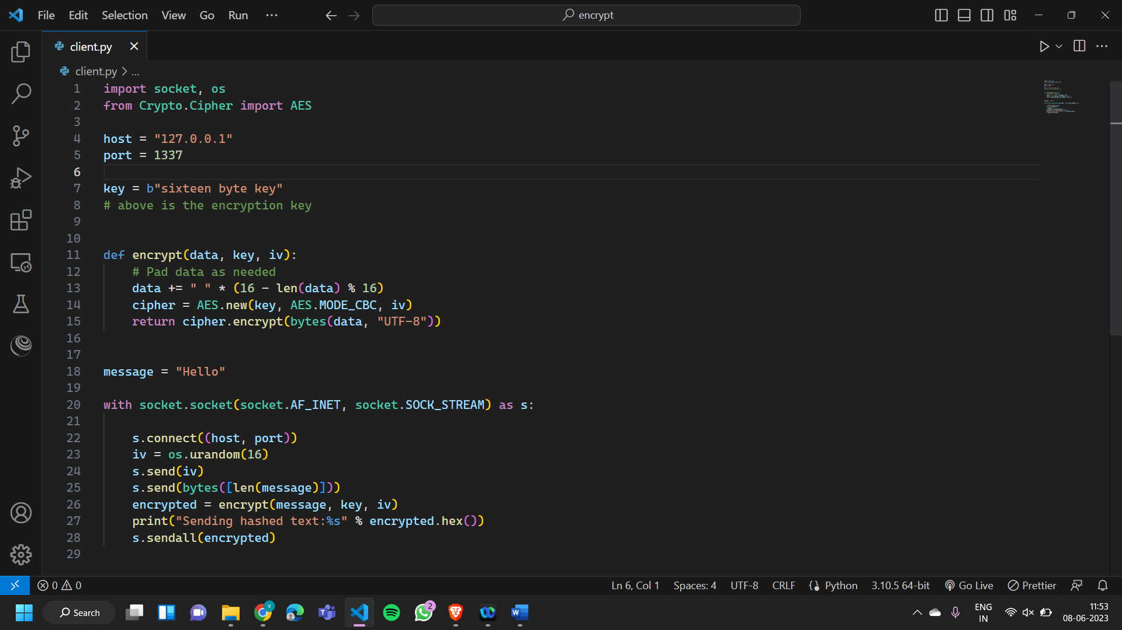

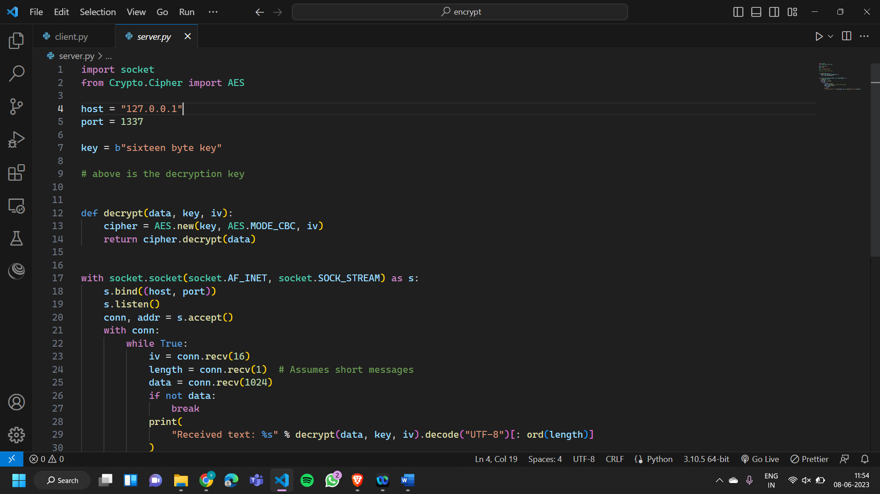

To implement this program first we connect the client server channels by typing the following commands on the terminal:

python client.py

python server.py

when the connection is established the client sends a hashed text to the server and the server receives the text and decrypts it into the plaintext.

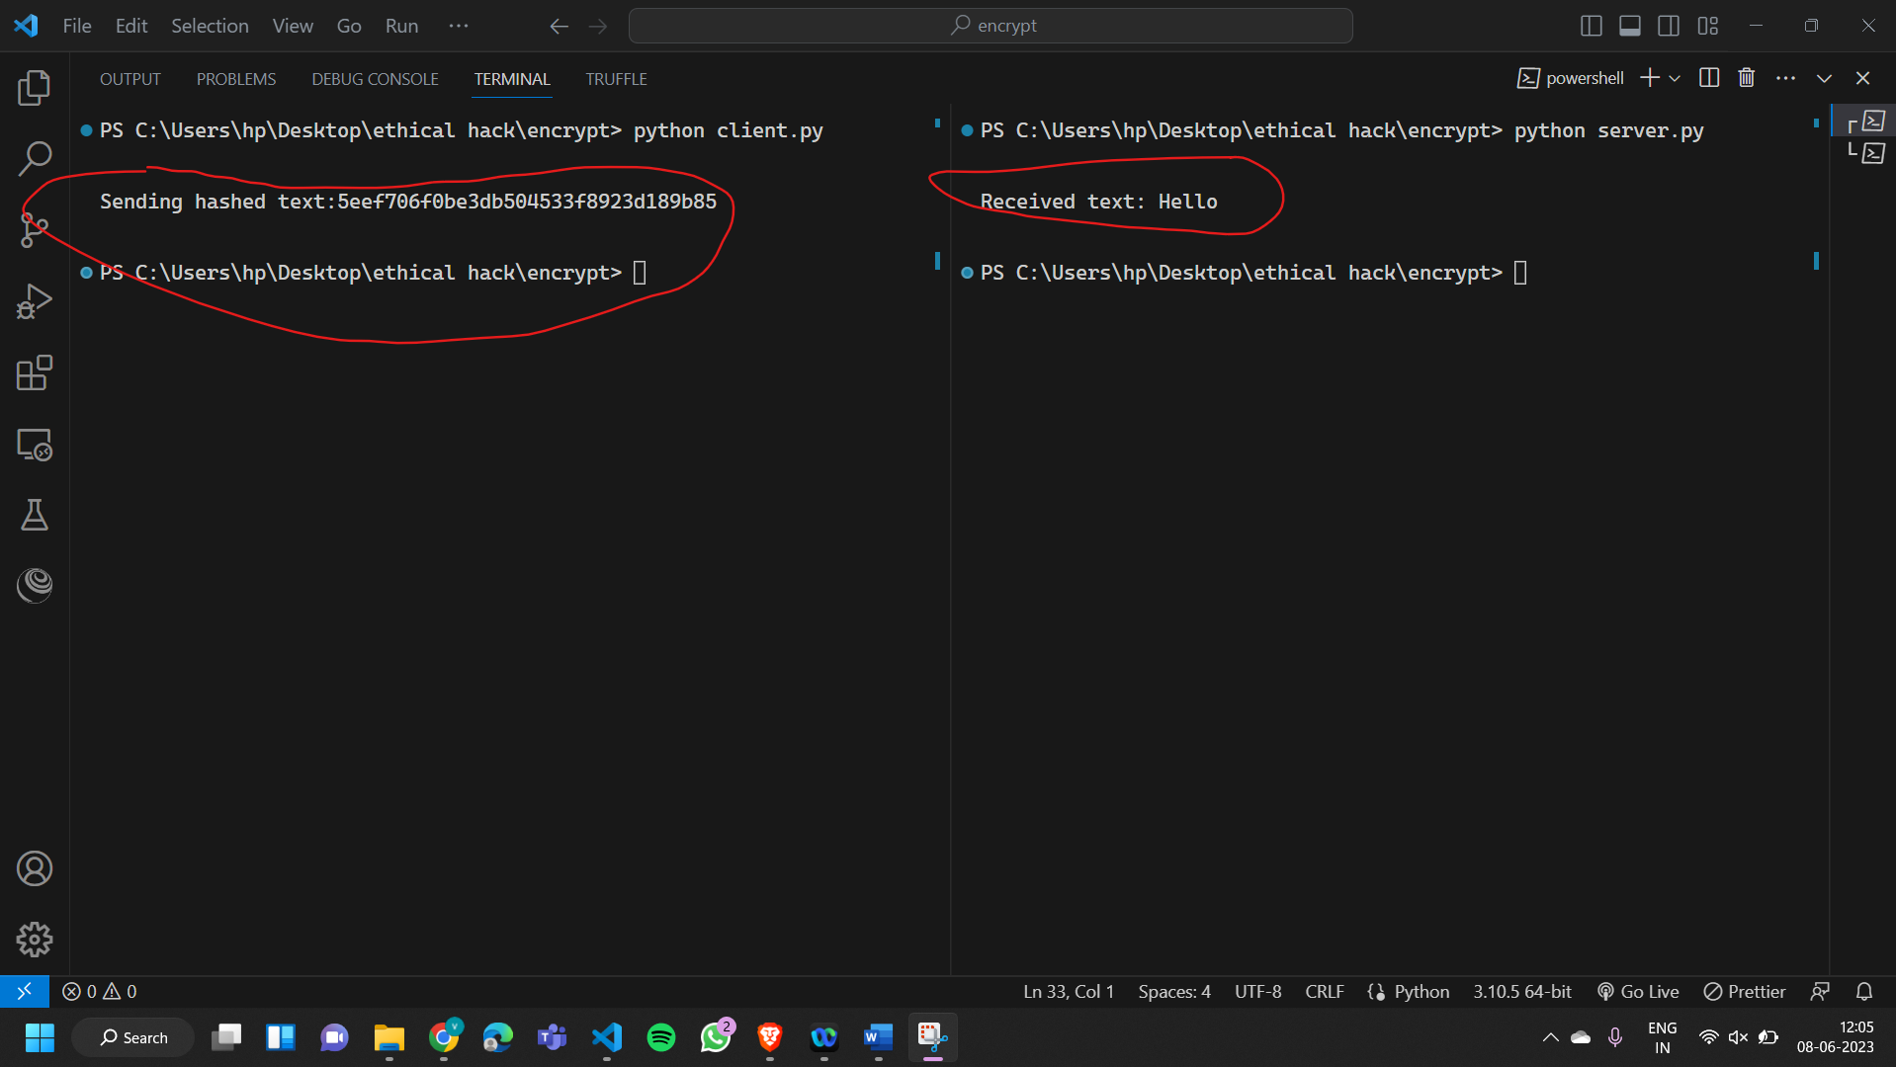

Security Analysis ->

Potential threats or vulnerabilities that could be exploited.

1. Insecure key management: The encryption key (**key = b"sixteen byte key"**) is hardcoded in the code, which is generally considered insecure. It is recommended to securely generate and manage encryption keys, such as using a key management system or storing keys in secure locations.
2. Lack of authentication: The code does not include any form of authentication between the client and server. This omission can make the system vulnerable to impersonation or man-in-the-middle attacks. Implementing mutual authentication using certificates or a secure authentication protocol is crucial for ensuring the identity and integrity of the communicating parties.
3. Insufficient input validation: The code does not perform input validation or sanitization on the received data, such as the length of the message or the IV (Initialization Vector). Without proper input validation, the system may be susceptible to buffer overflow attacks or other forms of input manipulation.
4. Weak encryption padding: The **encrypt** function in the client code uses a simple space padding scheme (**data += " " * (16 - len(data) % 16)**) to ensure the data length is a multiple of the block size. Space padding is not a secure padding scheme and can potentially be exploited. It is recommended to use stronger padding schemes, such as PKCS#7 padding.
5. Potential side-channel attacks: The code does not address potential side-channel attacks, such as timing attacks or power analysis attacks, which exploit information leaked during the encryption or decryption process. Implementing countermeasures, such as constant-time implementations or side-channel-resistant libraries, is necessary to mitigate these vulnerabilities.

Countermeasures or best practices to enhance the security of my implementation.

1. Key management: Instead of hardcoding the encryption key, use a secure key generation mechanism or a key management system. Store the keys securely and ensure they are properly protected. Regularly rotate and update the keys as required.
2. Authentication and integrity: Implement a robust authentication mechanism between the client and server, such as mutual TLS/SSL using certificates. This ensures the identity and integrity of the communicating parties, protecting against impersonation and man-in-the-middle attacks.
3. Input validation and sanitization: Validate and sanitize all input received from external sources, such as user input or network data. Ensure that the length of the message and the IV (Initialization Vector) is within expected limits and free from malicious or unexpected content. Implement appropriate error handling for invalid or malicious input.
4. Strong encryption padding: Replace the simple space padding with a secure padding scheme, such as PKCS#7 padding. It ensures that the data length is a multiple of the block size and provides stronger protection against padding oracle attacks.
5. Use secure encryption libraries: Utilize well-established and widely-audited encryption libraries, such as the Python Cryptography library, for implementing encryption and decryption functions. These libraries undergo rigorous security testing and receive regular updates to address vulnerabilities.
6. Secure communication channels: Encrypt the communication channel between the client and server using a secure transport layer, such as TLS/SSL, to protect against eavesdropping and data tampering.
7. Implement secure random number generation: Use a cryptographically secure random number generator (CSPRNG) to generate random values, such as the IV. In Python, the **secrets** module provides a secure random number generator.
8. Mitigate side-channel attacks: Implement countermeasures to mitigate side-channel attacks, such as timing attacks or power analysis attacks. This includes using constant-time implementations, ensuring consistent execution time regardless of the input, and utilizing side-channel-resistant cryptographic libraries.
9. Regular security assessments: Conduct regular security assessments, including code reviews and penetration testing, to identify and address any vulnerabilities or weaknesses in the implementation.

Conclusion ->  
Cryptography plays a crucial role in cybersecurity and ethical hacking. It provides the foundation for securing sensitive data, communications, and systems from unauthorized access and tampering. Encryption algorithms ensure confidentiality, integrity, and authenticity, protecting information from interception or modification by malicious actors. In ethical hacking, a deep understanding of cryptography helps identify vulnerabilities in cryptographic implementations, analyse encryption protocols, and assess the security of systems. It allows ethical hackers to test the strength of cryptographic controls, identify weaknesses, and help organizations strengthen their defences to ensure robust protection against cyber threats. Cryptography is an essential tool in both defensive cybersecurity and offensive security testing.